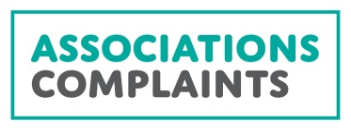
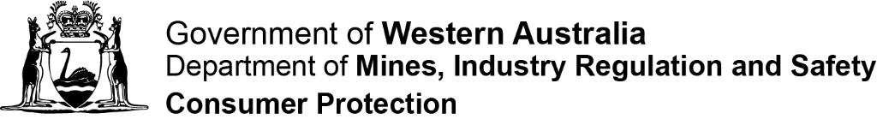

Complaint form:
INCORPORATED ASSOCIATIONS AND CHARITABLE COLLECTIONS
Use this form to make a complaint about an incorporated association registered in Western Australia or charitable collections.

YOUR DETAILS:

Title: Please choose one
☐ Mr. ☐ Mrs. ☐ Ms. ☐ Miss. ☐ Other – Specify Other
First name:
Last Name:
Address:
Preferred telephone number:
Email:
What is your relationship (if any) to the organisation? For example: member, committee member, volunteer, employee

WHO IS THE COMPLAINT ABOUT?

My complaint relates to: Please choose one
☐ An incorporated association ☐ A charitable collection
Name of organisation:
Address:
Contact person:
Telephone number:
Email address:

Are your concerns about a breach of an association’s rules? (often called the Constitution)
Consumer Protection is unable to intervene in internal disputes concerning the interpretation or application of an association’s rules (unless the issue also relates to the requirements of the Associations Incorporation Act 2015). If the dispute cannot be resolved using the association’s internal processes some matters may be considered by the State Administrative Tribunal.

Examples of matters that would need to be dealt with by members include:
- membership admissions, renewals or expulsions;
- the conduct of meetings (procedural matters);
- the processes and outcomes of committee elections;
- the inspection of records other than those referred to under the Act (being the register of members, rules and list of office bearers).

For information about options to resolve such matters please refer to the Resolving complaints and disputes section of the INC Guide available at www.commerce.wa.gov.au./inc.
COMPLAINT DETAILS
Please state clearly in the space below the full details of the issues you wish to raise.
(Please attach additional pages if required)

WHAT OUTCOME ARE YOU HOPING TO ACHIEVE?

ATTEMPTS TO RESOLVE YOUR CONCERNS
It is generally the role of members to resolve disputes about how the objects and purposes are pursued or whether the actions and decisions of a committee are appropriate and in the best interests of the organisation.
It is highly recommended that you make attempts to resolve your concerns with the organisation prior to lodging a formal complaint.
Have you approached the association or charity to try to resolve the concern?
☐ Yes ☐ No (Please choose one)

SUPPORTING DOCUMENTS
☐ I have attached copies of all the documents which support my allegations (please retain the originals of all documentation forwarded to Consumer Protection).

DECLARATION
To the best of my knowledge, the information supplied by me is true and correct.
Signature:
Date (dd/mm/yyyy):

I agree to my name being revealed in correspondence or during investigations concerning my complaint.
☐ Yes ☐ No (Please choose one)

Should you indicate that you do not wish to be identified, Consumer Protection will endeavour to protect your identity. However, the Department is bound by obligations under the Freedom of Information Act 1992 and may be requested to release information relating to the complaint.

LODGING THIS FORM

BY MAIL: Associations & Charities, Industry Regulation & Consumer Protection
Department of Mines, Industry Regulation and Safety
Locked Bag 100 EAST PERTH WA 6892
OR
BY EMAIL: notforprofitcomplaints@dmirs.wa.gov.au

If you need any assistance please contact the Associations and Charities Branch on 1300 30 40 74.

WHAT HAPPENS NEXT AND WHAT TO EXPECT
- You will receive an acknowledgment letter with the contact details of the officer assigned to the matter within four days of us receiving this complaint form and you will receive regular feedback regarding the progress of your complaint.
- You may be asked to provide further information and documentation to clarify or support any claims made in the complaint.
- If there appears to be a potential breach of legislation, the person or organisation that the complaint is about may be asked to comment on specific concerns raised.
- Consumer Protection seeks to encourage compliance where possible and will generally achieve this through education activities or by seeking remedial action, where appropriate. For more serious issues, a more formal enforcement approach may be required, which could include issuing a formal warning, infringement notice or prosecution.

