CO-OPERATIVE FORM 99

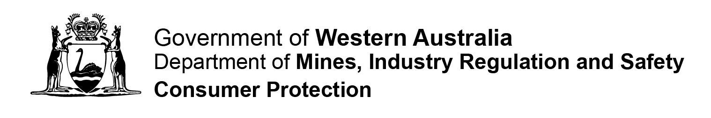

PAYMENT FORM

Date Received |  | Information  This payment form may be used for the payment of fees that are specified in the  Co-operatives Regulations 2009.  NO GST PAYABLE on these fees.  Please ensure this payment form is lodged along with the relevant application form.  Please refer to the current Schedule of Fees for information on the applicable fee. Details of the fee required for some application forms may be found overside.  Cheque or money order payments may be made payable to the Department of Mines, Industry Regulation and Safety.
Payment Details
Co-operative Name: …………………………………………………………………………….
………………………………………………………………………………………………………
Co-operative Registration Number: …………………………………………………………
Related Form: ……………………………………………………………………….…………..

Payment Type: Credit Card Money Order Cheque
IMPORTANT: Consumer Protection cannot accept debit/credit card details over the phone or email (including any attachments) in accordance with the Payment Card Industry Data Security Standards. If an email is received containing debit /credit card details, it will be deleted immediately and your application and payment will not be processed.
Credit Card Payment:

Mastercard VISA
Card Number: __ __ __ __ __ __ __ __ __ __ __ __ __ __ __ __
Expiry Date: __ __ / __ __ Amount: $ ……………………………………......
Name on Card: …………………………………………………………………………………..
Cardholders Signature: ….….………………………………………………………..…………
Contact Details (in case of enquiries):
Name: …………………………………………………………………………………………..
Address: ………………………………………………………………………………………….

Phone ( )……………………………… Email: ……………………………………………..

