CO-OPERATIVE FORM 36

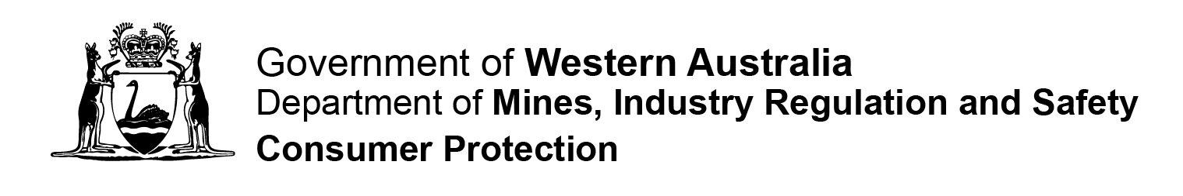

STATUTORY DECLARATION IN SUPPORT OF A SPECIAL RESOLUTION (OTHER THAN FOR ALTERING RULES)

Fm36 P |  | Instructions  Please complete in BLOCK LETTERS. Attach extra pages if needed. All references to dates should be in DD/MM/YYYY format.  Privacy Statement – Please Read  The Department of Mines, Industry Regulation and Safety, Consumer Protection Division (Consumer Protection) is collecting information on this form for the purposes of the Co-operatives Act 2009 (the Act).  In accordance with the Act, a register of this information and any documents lodged with the Registrar will be available for inspection by the public upon payment of a prescribed fee. In other instances, information on this form can be disclosed without your consent where authorised or required by law.

Date Received

Part 1 – Application Details
Section 1  Application Details | Name of Co-operative: ……………………………………………………………………….  …………………………………………………………………………………………………….  Co-operative Registration Number: ……………………………………………………….
Section 2  Statutory Declaration  This form must be declared before a qualified witness in accordance with the Oaths, Affidavits and Statutory Declarations Act 2005 (WA) | I ………………………………………………………………………….. (insert full name), being the Chairperson of the meeting / Returning Officer of a ballot at which the above named co-operative voted on a special resolution, do solemnly and sincerely declare that:  - The meeting / declaration of the ballot was held on __ __ / __ __ / __ __ __ __ ; and  - The Co-operatives Act 2009 and the rules of the co-operative relating to the calling and conduct of the meeting or postal ballot / special postal ballot and the passing of the special resolution were duly complied with.  I make this solemn declaration conscientiously believing the same to be true and by virtue of the provisions of the Oaths, Affidavits and Statutory Declarations Act 2005 (WA).  Signature of Chairperson / Returning Officer: …. ………………………………………..…  Declared before ………………………………………………..on __ __ / __ __ / __ __ __ __  Signature of Witness: ………………………………………………………………………….
Lodgement Details

Please Note
This application should only be lodged in conjunction with Form 35.
Should you require further assistance please contact our office on 1300 304 074
 | Lodgement by Mail:  Department of Mines, Industry Regulation and Safety  Consumer Protection Division  Associations & Charities Branch  Locked Bag 100  EAST PERTH WA 6892 |  | Lodgement in Person:  Department of Mines, Industry Regulation and Safety  Consumer Protection Division  Level 1, Mason Bird Building  303 Sevenoaks Street  CANNINGTON WA

