 | 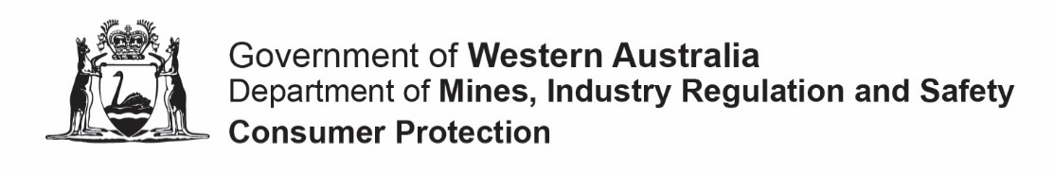

FORM 04
Notification of an incorporated associations address
Associations Incorporation Act 2015 s7, 103, 174 and 203
Purpose  This application form should be used to notify the Commissioner for Consumer Protection of the association’s address and postal address for service of notice under the Associations Incorporation Act 2015 (the Act).  WARNING: It is an offence to fail to lodge this notice either within 90 days of the new laws commencement or 28 days of the change occurring.  Instructions  - Type directly into this form electronically before printing and signing it or hand print neatly using an ink pen in block letters. |  |  |  |  |  |  | OFFICE USE ONLY
SECTION A: INCORPORATED ASSOCIATION PARTICULARS
- What is the name of the incorporated association?
The association’s name as shown on the certificate of incorporation.
- What is the incorporated association’s registration number (IARN):
SECTION B: ADDRESS PARTICULARS
- What is the association’s new address?
Provide the association’s email and the address you want the Department to use to send communication to. The email address should not be a personal email.
Street
Suburb
State |  |  |  |  | Postcode
Email
- What is the association’s new address for service?
The address for service is the address that you want the public to use to contact the association.
Tick if the same as the new association’s address.
Street
Suburb
State |  |  |  |  | Postcode
SECTION C: AUTHORISED PERSONS PARTICULARS & DECLARATION
Provide the name and particulars of the person making this application:
Any correspondence about this application will be sent to this person.
I certify that:
- I am authorised by the association's committee to lodge this application under the Act;
- I acknowledge that it is an offence under section 177 of the Act to make a false and misleading declaration in relation to this application
Signed |  |  |  |  | Date
Title |  |  | Mr Mrs Ms Miss Other ______________________________________
Name |  |  |  |  | Surname
Street or PO
Suburb
State |  |  |  |  | Postcode
Telephone |  |  |  |  | Mobile
Email
IMPORTANT: Before you submit this form, check that you have provided true and correct information.
Privacy Statement – please read. The Department of Mines, Industry Regulation and Safety, Consumer Protection Division is collecting and holding information supplied for the purposes of the Act. In accordance with this legislation, a copy of this form and the information it contains will be available for purchase by the public upon payment of a prescribed fee.
LODGING THE APPLICATION FORM
You may lodge the application.
By post:  Department of Mines, Industry Regulation and Safety  Consumer Protection Division  Associations and Charities Branch  Locked Bag 100  EAST PERTH WA 6892 |  |  |  | In person: (8.30 am to 4.30pm weekdays)  Department of Mines, Industry Regulation and Safety  Consumer Protection Division  Level 2, Gordon Stephenson House  140 William Street  PERTH WA
For assistance call our information line on 1300 304 074 or (08) 6552 9300 (8.30 am to 4.30pm weekdays)

Our online portal AssociationsOnline can be used to submit this application electronically. For more information please visit www.dmirs.wa.gov.au/associationsonline

