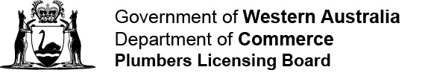

Record of emergency plumbing work in remote Aboriginal communities
Part 4A of the Plumbers Licensing and Plumbing Standards Regulations 2000

Service provider: Community:

Date work completed | Category of work | Address | Authorised worker | Notes

Category of work
(a) | replacing leaking tap washers, spindles, handles and shower roses (except when additional plumbing work is required)
(b) | replacing “P-Traps” and “S-Traps” in readily accessible locations, such as under sinks, basins or troughs
(c) | replacing leaking hose taps and hose tap vacuum breakers
(d) | replacing leaking cistern inlet and outlet washers and valves
(e) | capping a burst water main, damaged waste pipe or sanitary drain for the purposes of preventing a risk to human health or safety or a significant waste of water
(f) | replacing general covers (e.g. missing or broken inspection mounds, gully mounds, grates and vent cowls)
(g) | clearing blocked waste pipes and drains by the use of plungers, flexible hand rods or hand-held water hoses only
(h) | unblocking toilets, showers, basins, troughs, sinks and baths by the use of plungers, flexible hand rods or hand-held water hoses only

