Review Process Summary – Develop Work Health and Safety Regulations for Western Australia

Contents
1 Introduction 3
2 Background 3
3 Proposal 3
Three sets of WHS regulations 4
Dangerous goods and major hazard facilities 5
Diagrams of the structure for the WHS regulations 6
4 December 2018 Review of the national model Work Health and Safety laws – Final Report 7
5 Transition principles 7
6 Public consultation 8
Submissions publicly available 8
Making a submission 8
Submission requirements 9
7 Next steps - After the public consultation period ends 9
8 List of internet links in the Consultation Package 9
WHS regulations applying generally to workplaces 9
Mining sector 10
Petroleum and Geothermal Energy Operations 10

1 Introduction
This Consultation Package has been prepared to facilitate consultation with stakeholders in relation the regulations that will support the proposed Work Health and Safety Act for Western Australia (WHS Act (WA)). The proposed WHS Act (WA) will be applicable to general workplaces, mining and petroleum/geothermal operations industries. Therefore, the proposed regulations will cater for all these industries. The Consultation Package contains links to relevant documents and explains the structure and content of the proposed regulations.

2 Background
On 3 July 2008, the Council of Australian Governments (COAG) formally committed to harmonising the occupational safety and health laws in Australia by signing the Intergovernmental Agreement for Regulatory and Operational Reform in Occupational Health and Safety (OHS IGA). The primary goal of the OHS IGA was to develop harmonised legislation, regulations and codes of practice that could be adopted in all Australian jurisdictions.

To facilitate the process of modernising Western Australia’s safety and health laws, in June 2017, Cabinet established the Ministerial Advisory Panel on Work Health and Safety Reform (MAP). The purpose of the MAP was to provide the Minister for Mines and Petroleum; Industrial Relations (Minister) with advice on the development of a single harmonised and amalgamated WHS Act (WA) and based on the national model Work Health and Safety (WHS) Act. The WHS Act (WA) is intended to cover general workplaces, mines and petroleum and geothermal energy operations in Western Australia.

The MAP:
- provided its recommendations for the WHS Act (WA) to the Minister in April 2018; and
- included observations for Western Australia’s WHS Regulations.
The MAP’s WHS Act (WA) proposals were approved by the Minister for a public consultation period that commenced on 1 July 2018 and ended on 31 August 2018. The Minister has provided proposals to Cabinet.

3 Proposal
Now that the public consultation phase in relation to the WHS Act (WA) has progressed, the Minister has:
- confirmed a preference for the WHS Act (WA) to be supported by three sets of industry specific regulations to recognise the State’s unique conditions; and
- indicated, subject to public consultation, the intention to adopt the 15 January 2019 National Model Work Health and Safety Regulations (model WHS regulations).

The proposed three sets of regulations are:
- WHS regulations applying generally to all Western Australian workplaces;
- WHS regulations applying to the mining sector; and
- WHS regulations applying to petroleum and geothermal energy operations.

In conjunction with the introduction of the three separate sets of WHS regulations, the OSH regulations and workplace safety and health provisions in related mines and petroleum regulations will be repealed. The:
- WHS Regulations will apply generally to workplaces including the mining industry. Some of these regulations will also apply to petroleum and geothermal operations. These details are provided later.
- Work Health and Safety (Mines) Regulations will apply to mines only.
- Work Health and Safety (Petroleum and Geothermal Energy Operations) Regulations will apply to petroleum and geothermal energy operations only.

Three sets of WHS regulations
The three sets of proposed regulations are based on the following general principles:
- The WA WHS regulations will:
  - be based on the 15 January 2019 model WHS regulations;
  - apply to all Western Australian workplaces;
  - not include:
    - Chapter 2 Representation and participation, Part 2.4 – Workplace entry by WHS entry permit holders;
    - Chapter 9 – Major Hazard Facilities and Part 10 - Mines in the WHS regulations applying generally to workplaces; and
    - Schedules relating to Major Hazard Facilities;
  - edit Chapter 7 – Hazardous Chemicals and associated schedules to remove duplication with Western Australia’s dangerous goods legislation; and
  - include some unique provisions from the Occupational Safety and Health Regulations 1996.
- Mining Sector:
  - the WA WHS regulations will apply to mine sites;
  - additional mines specific regulations WHS (Mines) regulations will apply based on:
    - work done by the three dominant mining states and the National Mine Safety Framework;
    - the mining sector continuing to use a risk-based approach; and
    - some provisions (radiation and electricity) from the Mines Safety Inspection Regulations 1995;

- Petroleum and Geothermal Energy Operations:
  - will continue to operate under ‘Safety Case’;
  - existing regulations have been streamlined; and
  - will be subject to some of the regulations in the WHS regulations applying generally to workplaces.
As a result of these requirements, the bulk of the WHS Regulations will not apply to the Petroleum and Geothermal sector.
To avoid unnecessary duplication, it is anticipated that the following Parts of the model WHS Regulations will apply to Petroleum Operations:
- Chapter 2 Representation and Participation – Parts 2.1, 2.2, 2.3, 2.4, which provides for workplace consultation, Health and Safety Representatives, and Safety Committees
- Chapter 3 General Risk and Workplace Management – Part 3.1
- Chapter 11 Miscellaneous – Part 11.3, which provides for the clarification of miscellaneous matters.
- Schedule 10 Prohibited carcinogens, restricted carcinogens and restricted hazardous chemicals. This Schedule will replace provisions in the three sets of occupational safety and health regulations that relate to petroleum and geothermal energy operations.
Other than the Parts listed above, it is proposed that the remainder of the WA WHS regulations will be dis-applied from petroleum and geothermal energy operations.

Dangerous goods and major hazard facilities
Dangerous goods and major hazard facilities will remain under dangerous goods legislation. However, the approach to dangerous goods, including major hazard facilities, will be reviewed within two years of the WHS Act (WA) being proclaimed in Western Australia, with a view to determining whether dangerous goods and major hazard facility regulations are brought under the WHS Act.
Because the Dangerous Goods Safety Act 2004 and its regulations will continue to operate, there will be some overlap between the dangerous goods legislation and Chapter 7 – Hazardous chemicals of the model WHS regulations. To address this overlap, it is proposed that some model WHS regulations are deleted. The proposed deletions, with explanation, are detailed in: Proposed deletions in Western Australia to remove overlap with the Dangerous Goods Safety Act 2004
Schedules (11, 12 & 13) are also proposed for deletion.
Matters covered by these hazardous chemicals regulations include, packaging and age restrictions for supply, manifest quantities, placard requirements, emergency plans, storage and handling systems and pipelines. There will also be consequential amendments to definitions and Schedules in the WHS regulations.

Diagrams of the structure for the WHS regulations
The diagrams below:
- give the proposed structure for the Western Australian:
  - WHS regulations;
  - WHS (Mines) regulations; and
  - WHS (Petroleum and Geothermal Energy Operations) regulations
- recognise that dangerous goods legislation will be subject to further consideration.
WHS REGULATIONS
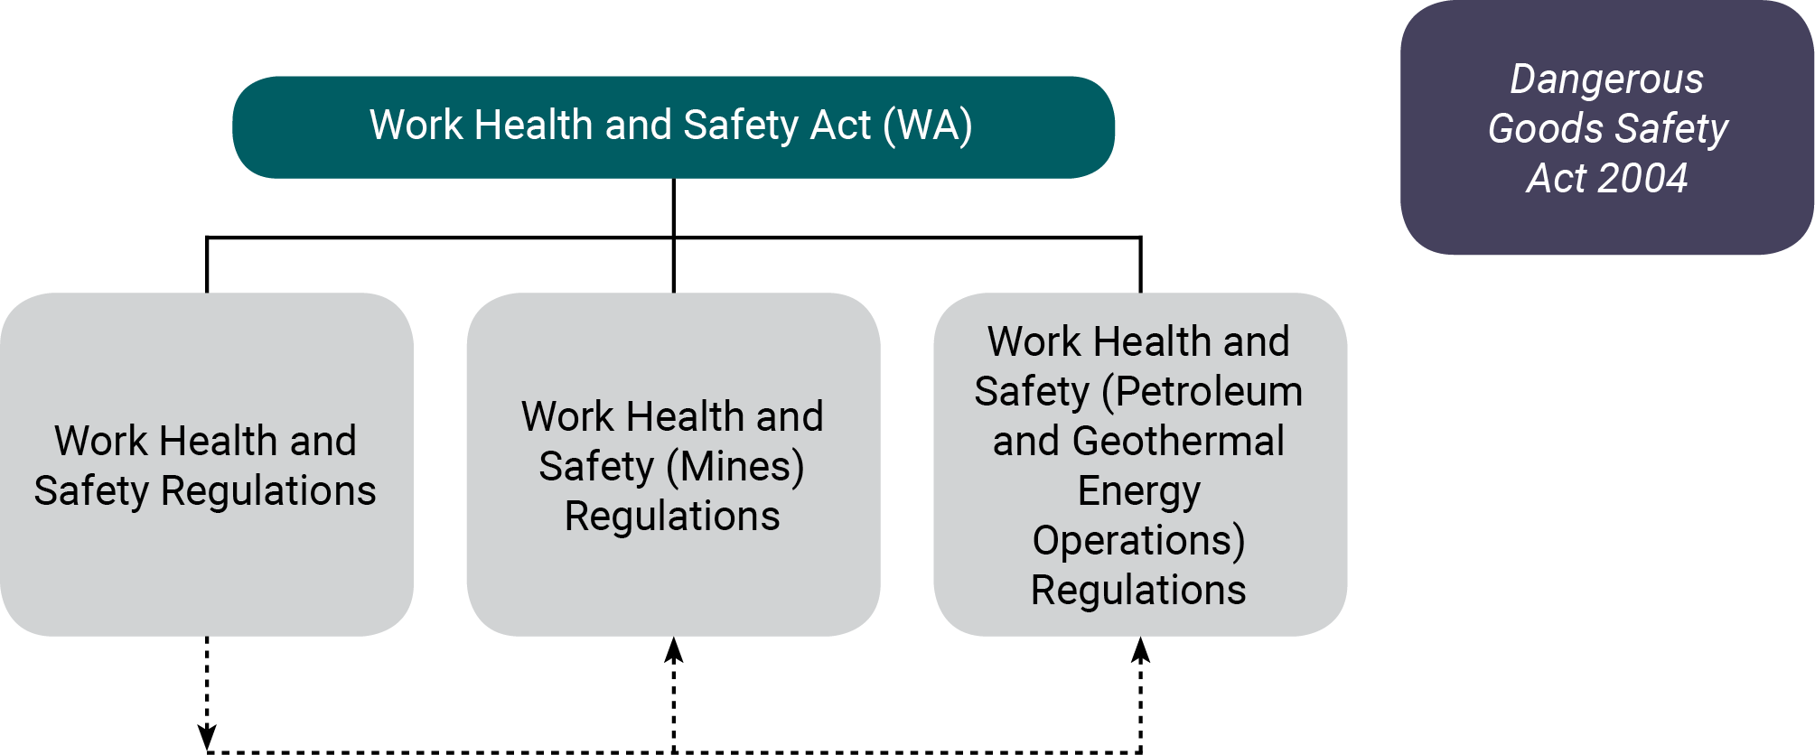

MINING SECTOR
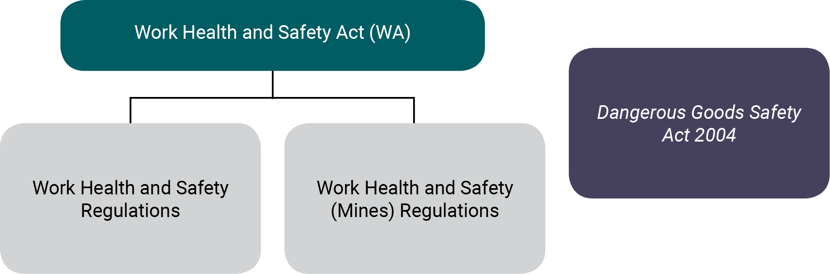

PETROLEUM AND GEOTHERMAL ENERGY OPERATIONS
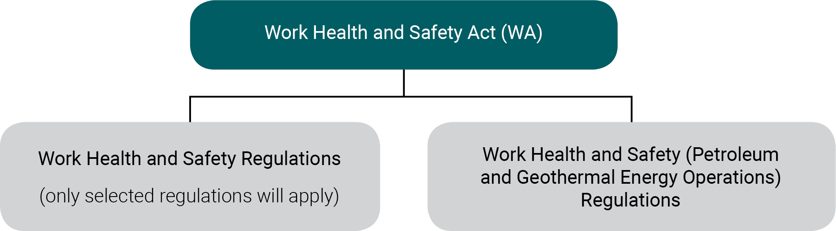

4 December 2018 Review of the national model Work Health and Safety laws – Final Report
The December 2018 Review of the national model Work Health and Safety laws – Final Report (WHS review report) was prepared at the request of the Ministers with responsibility for work health and safety matters. The review of the national model WHS laws was conducted in 2018 by Ms Marie Boland (an independent reviewer) and examined how the model WHS laws are operating in practice. The review found the laws are largely operating as intended, but that some changes are needed to provide clarity and to drive greater consistency in the application and enforcement of the laws across jurisdictions.

The WHS review report has 34 recommendations. Many recommendations are technical, relating to inspectors’ powers or relating to specific regulations such as amusement devices and asbestos registers. You may want to consider the WHS review report to help inform your submission. The WHS review report provided by Ms Boland has been published and is available from Safe Work Australia.

5 Commission for Occupational Safety and Health
The Commission for Occupational Safety and Health (Commission) has endorsed consideration of the following suggestions during the consultation process. The endorsement does not necessarily reflect the view of individual members of the Commission. Suggestions are:
- Confined space definition (r. 5). The definition in the model WHS regulations excludes “a mine shaft or the workings of a mine” from the definition of confined space. Stakeholder comment is requested as to whether it is appropriate to limit the exclusion to “underground mines”.
- In relation to tree lopping, r. 221 of the model WHS regulations provides an exception for a person in a harness to be placed in a tree. This procedure is not currently permitted under r. 4.53(2) of the OSH regulations. Should r. 221 of the model WHS regulations be adopted in Western Australia?
- R. 244(3) of the model WHS regulations exempts tower and gantry cranes from design registration if the cranes are moved to a new location. R. 4.2 of the OSH regulations currently requires the registration of the cranes and their supporting structure if moved to a new location. Should r. 4.2 of the OSH regulations be adopted?
- R. 376 of the model WHS regulations places a duty on the PCBU to provide a copy of the health monitoring report to the regulator. Under, r. 5.24 of the OSH regulations, the duty to provide the health monitoring report to the WorkSafe Western Australia Commission is on the appointed medical practitioner who prepared the report, if the results indicate exposure. Should r. 5.24 of the OSH regulations be adopted?
- R. 320 of the model WHS regulations prescribe the content of the general construction induction training (CIT) card. Should there be a requirement that photographic identification is required on the CIT card?
- R. 425 of the model WHS regulations requires a person with management or control of a workplace to ensure that an asbestos register is prepared and kept at the workplace. Should the WHS regulations for Western Australia prescribe that an asbestos register is created by a competent person?
- The model WHS regulations, Chapter 8 in particular, include requirements relating to the management of asbestos. Should the WHS regulations for Western Australia prescribe specific competencies for asbestos related tasks?

When providing your views in relation to these matters identified by the Commission for consideration, please provide reasons for your views and supporting evidence.

6 Transition principles
Safe Work Australia published the Model Work Health and Safety Regulations - Transition Principles (SWA Transition Principles) which:
- were used as guidelines by other jurisdictions when adopting the model WHS regulations;
- are designed to ensure a smooth transition to the harmonised WHS laws; and
- are proposed to be used to determine the commencement date for the WHS regulations in Western Australia.
It is intended that the SWA Transition Principles will similarly apply in Western Australia during the process to adopt WHS regulations. If you would like to make comment about the SWA Transition Principles, please include those comments with your submission.

7 Public consultation
The Minister has approved DMIRS commencing consultation to develop recommendations for the proposed adoption of the national model WHS regulations. The Minister may decide to adopt the package of WHS regulations with changes to suit Western Australia as identified during the public consultation process.
The public consultation period:
- commences 26 August 2019
- ends 26 November 2019.

In order for advice to be prepared for the Minister as requested, submissions are requested from industry stakeholders and others interested in workplace health and safety to provide comments about:
- National Model Work Health and Safety Regulations
- To help facilitate the WA WHS regulations being developed, the Commission requested that the differences between the model WHS regulations and the OSH regulations be identified. As a result of the request, the document titled Differences Between the national model Work Health and Safety Regulations and the Occupational Safety and Health Regulations 1996 was developed.
- Proposal for Work Health and Safety (Mines) Regulations for Western Australia
This consultation document has been developed by DMIRS in consultation with key mining stakeholders; and
- Proposal for Work Health and Safety (Petroleum and Geothermal Energy Operations) Regulations for Western Australia
This consultation document has been developed by DMIRS in consultation with key petroleum, geothermal energy and pipeline operator stakeholders.

Submissions publicly available
All submissions will be published on the DMIRS website soon after the public comment period ends, unless you specify that your submission is confidential.

Making a submission
The purpose of this Consultation Package is to encourage workplace participants, or any person interested in workplace health and safety in Western Australia, to provide comments about adopting the WHS regulations for Western Australia.

It is important that new WHS regulations are appropriate for Western Australia. Your views:
- are sought on any aspect of the national model WHS regulations and the proposals for the mining and petroleum and geothermal sectors that might impact Western Australian workplaces;
- can relate to:
  - individual regulations;
  - your business or daily work; and
  - community related issues.

In providing your views, you might consider the following questions:
- What is the likely cost for you, your business, and the Regulator to implement a specific proposal?
- What is the benefit to workplace participants?
- Is a specific recommendation likely to be effective in achieving healthier and safer workplaces?
- Are there any unintended consequences of adopting individual regulations in the model WHS regulations?
- If a new requirement is proposed by the model WHS regulations, what are the costs and benefits?
Please also note:
- These questions are there to assist you identify issues. Please do not feel restricted to these questions if you have other matters you would like to raise.
- You do not have to address every regulation in the model WHS regulations or proposal for the mines and petroleum and geothermal energy operations regulations.
- Your submission can address as many, or as few, regulations or proposals as you want.

Submission requirements
Anyone with an interest in workplace health and safety is invited to make a submission on any matter relating to the:
- WA WHS regulations based on the model WHS regulations;
- WHS (Mines) regulations; and
- WHS (Petroleum and Geothermal Energy Operations) regulations.
All submissions must be accompanied by the Coversheet Work Health and Safety Regulations Submission.

Your completed coversheet and submissions may be sent by email or mail as outlined below:
Email: WHSreform@dmirs.wa.gov.au
Mail: WHS Reform
Locked Bag 100
EAST PERTH WA 6892
PLEASE MARK YOUR ENVELOPE ‘FOR THE ATTENTION OF THE DEPUTY DIRECTOR GENERAL, SAFETY REGULATION – SUBMISSION ON WHS REGULATIONS
Note: All commonly accessible electronic formats will be accepted for submissions but Word documents are preferred.

8 Next steps - After the public consultation period ends
After the public consultation period ends, the submissions will be provided to the Minister in order to facilitate his decision in relation to adopting the model WHS regulations in Western Australia.

9 List of internet links in the Consultation Package
WHS Consultation Package includes a number of links to documents. A list of the links is provided below and categorised in alphabetical order under the three sets of regulations.

WHS regulations applying generally to workplaces
  - Differences Between the national model Work Health and Safety Regulations and the Occupational Safety and Health Regulations 1996
  - National Model Work Health and Safety Regulations 15 January 2019
  - Occupational Safety and Health Regulations 1996
  - Occupational Safety and Health Amendment Regulations 2017 (Electrical Amendment Regulations)
  - Occupational Safety and Health Regulations 1996 - Commercial driver fatigue – (r. 3.130 to 3.134)
  - Occupational Safety and Health Regulations 1996 - Demolition licensing (r. 3.114 to r. 3.129)
  - Occupational Safety and Health Regulations 1996 - Protection from Tobacco Smoke (r. 3.44A to 3.44I)
  - Transition Principles - Model Work Health and Safety Regulations, Safe Work Australia

Mining sector
  - Mine Safety and Inspection Regulations 1995
  - National Mines Safety Framework – Drafting Instructions
  - Proposals for Work Health and Safety (Mines) Regulations for Western Australia

Petroleum and Geothermal Energy Operations
  - Petroleum and Geothermal Energy Resources Act 1967, Petroleum (Submerged Lands) Act 1982
  - Petroleum and Geothermal Energy Resources (Management of Safety) Regulations 2010
  - Petroleum and Geothermal Energy Resources (Occupational Safety and Health) Regulations 2010
  - Petroleum Pipelines Act 1969
  - Petroleum Pipelines (Occupational Safety and Health) Regulations 2010
  - Petroleum (Submerged Lands) Act 1982
  - Petroleum (Submerged Lands)(Management of Safety on Offshore Facilities) Regulations 2007
  - Petroleum (Submerged Lands)(Pipelines) Regulations 2007
  - Petroleum (Submerged Lands)(Diving Safety) Regulations 2007
  - Petroleum (Submerged Lands)(Occupational Safety and Health) Regulations 2007
  - Petroleum Pipelines (Management of Safety of Pipeline Operations) Regulations 2010
  - Proposals for Work Health and Safety (Petroleum and Geothermal Energy Operations) Regulations for Western Australia

