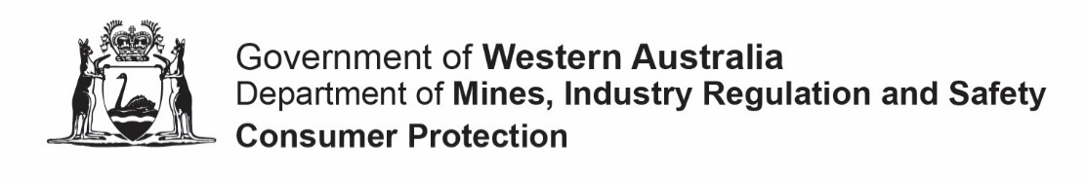
FORM 09R |  | This form is effective from September 2023
Application requesting copies of documents
Associations Incorporation Act 2015 s20
Please read this information before completing this form
ABOUT THIS FORM
This form is to be used to obtain a replacement certificate of incorporation under the Associations Incorporation Act 2015 because the original certificate issued to the association has been lost or destroyed.
RELATED INFORMATION
- If the original certificate has not been lost or destroyed and the association wants to confirm its current status it may purchase an Extract using the Form 09. The Extract contains:
  - the association’s current name,
  - registration number (IARN),
  - date of incorporation or cancellation,
  - current address for service of notice,
  - current status,
  - tier,
  - financial year end,
  - date of its last annual general meeting, and
  - the type of rules it is using.
FEES
Visit our fees forms and online transactions page for current application fees. GST is not payable on these fees.
HOW TO LODGE AND PAY
You can lodge online using our AssociationsOnline portal or else complete this form and return it, together with any supporting documents, using one of the following methods
  In person | Pay in person using cash, cheque, money order or card (debit or credit) via our customer service counter at:  Level 1, Mason Bird Building,  303 Sevenoaks Street  CANNINGTON  Hours: 8:30 am to 4:30 pm (weekdays)
  Post | Pay by mail with cheque or money order to:  Department of Mines, Industry Regulation and Safety  Associations & Charities Branch  Locked Bag 100  EAST PERTH 6892  Make cheques and money orders payable to “Department of Mines, Industry Regulation and Safety”
NOTE: From September 2023, the Department will not accept payments by credit card for mailed forms. Card payments can only be made in person at our cashiering services.

WHAT HAPPENS NEXT
- The replacement certificate will be issued digitally by email to the nominated contact person, usually within 10 working days.
- You will be advised if the replacement certificate is unable to be issued.

CONTACT
For assistance with completing this form, or information about the progress of an application, contact the Associations and Charities Branch by:
Telephone | 1300 30 40 74 or (08) 6552 9300 (8:30 am to 4:30 pm weekdays)
Email | associations@dmirs.wa.gov.au
Website | www.dmirs.wa.gov.au/associations

The above information is intended as a guide only and is included to assist you in completing and lodging this form. This page is not part of the form. If required, professional advice should be obtained regarding the matters dealt with in this form.

FORM 09R
Application requesting replacement certificate of incorporation
Associations Incorporation Act 2015 s20
This form should be used by an association to request the issue of a replacement certificate.  Instructions  - Type directly into this form electronically before printing and signing it or hand print neatly using an ink pen in block letters.  - Complete all sections in every case.  - Keep a copy of this form for your own records. |  |  |  |  |  |  |  |  |  | OFFICE USE ONLY
SECTION A: INCORPORATED ASSOCIATION PARTICULARS
Incorporated association’s name |  |  |  |  |  |  |  |  |  |  |  |  |  | IARN
The reason for requesting the issue of a replacement certificate is due to the original certificate being:
 | Lost or mislaid
 | Destroyed
SECTION B: APPLICANT
Provide the name and particulars of the person making this application:
I declare that:
- I am a duly elected committee member or person authorised to act on behalf of the incorporated association named in this form;
- the association’s original certificate of incorporation has been lost, mislaid or destroyed;
- the information contained within this application is to the best of my knowledge true and correct; and
- I understand that it is an offence under section 177 of the Act to make a false and misleading declaration in relation to this application
Signed |  |  |  |  |  | Date
Title |  |  |  | Mr Mrs Ms Miss Other _________________________________
Name |  |  |  |  |  |  | Surname
Address
(Street or PO)
Suburb |  |  |  |  | State |  |  |  | Postcode
Email |  |  |  |  |  |  | Telephone
IMPORTANT: Before you sign this form, check that you have provided true and correct information.

CONTACT FOR THIS APPLICATION
Where should we send the replacement certificate?
 | The applicant (submitter)
 | Another person Provide the contact’s details below:
Title |  | Mr Mrs Ms Miss Other ______________________________________
Name |  |  |  | Surname
Address
(Street or PO)
Suburb |  |  | State |  |  | Postcode
Email |  |  |  | Telephone

