 | 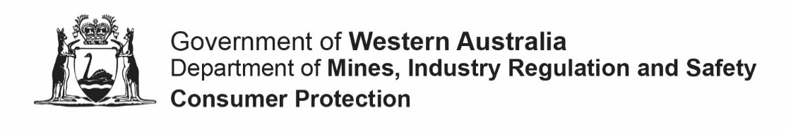
 | Form 99A |  |  |  |  |  | This form is effective from 1 November 2023
 | Co-operative document request form
 | Please read this information before completing this form
 | About this form
 | Use this form to access documents lodged with the Department relating to a co-operative registered under the Co-operatives Act 2009 upon paying the relevant fee.
 | Fees
 | Please refer our Co-operatives fees and forms webpage for the current fees. Fees are exempt from GST and subject to change without notice.
 | How to lodge and pay
The completed form should be emailed to cooperatives@dmirs.wa.gov.au
Once Consumer Protection has received the request form you will be contacted with quotation for the cost for your order. There is no obligation to proceed with the request and the documents sought may be altered during this time.
If you proceed with the request, you will be issued with an invoice that you can pay using one of the following methods:
 | In person: |  |  |  |  |  |  |  |  | Bring the invoice to our cashier counter services located at:  Level 1, Mason Bird Building  303 Sevenoaks Street  CANNINGTON  Hours: 8:30 am to 4:30 pm (weekdays)
 | By post |  |  |  |  |  |  |  |  | Attach a cheque or money order made out made payable to “Department of Mines, Industry Regulation and Safety” to the invoice and post it to:  Department of Mines, Industry Regulation and Safety - Consumer Protection,  Associations & Charities Branch  Locked Bag 100  EAST PERTH WA 6892
 | Online |  |  |  |  |  |  |  |  | Make payment by credit card or Bpay using the Department’s secure online payment gateway at https://payportal.dmirs.wa.gov.au/
 | Contact
 | If you need assistance completing this form, more information about the status of your application or general information about co-operatives please contact us
 | Telephone |  |  |  | 1300 30 40 74 or (08) 6552 9300 (8:30 am to 4:30 pm weekdays)
 | Email |  |  |  | cooperatives@dmirs.wa.gov.au
 | Website |  |  |  | www.dmirs.wa.gov.au/co-ops
Form 99A |  |  |  |  |  |  |  | This form is effective from 1 July 2023
Co-operative document request form
SECTION 1 – REQUEST DETAILS
 |  | Provide details of the co-operative that you require documents about:
 |  | If you require documents relating to more than one co-operative, please copy this page.
 |  | Registration number
 |  | C
 |  | Co-operative name
SECTION 2 – DOCUMENTS REQUIRED (U = uncertified | C = certified copy)
 |  | Select the documents that you require for the co-operative:
 |  | ☐ | Extract (includes name, registration status, date of registration/deregistration, type, primary activity, registered office and current directors)
 |  | ☐ | U | ☐ |  | C |  |  | Co-operatives rules |  |  |  | ^{Approximate lodgement date}
 |  | ☐ | U | ☐ |  | C |  |  | Annual return to the Registrar (Form 10) |  |  |  | ^{Year of return:}
 |  | ☐ | U | ☐ |  | C |  |  | Notification of changes to directors and officers (Form 13) |  |  |  | ^{Approximate lodgement date:}
 |  | ☐ | U | ☐ |  | C |  |  | Notification of changes to registered office (Form 14) |  |  |  | ^{Approximate lodgement date:}
 |  | ☐ | U | ☐ |  | C |  |  | Other documents |  |  |  | Specify document type and lodgement date:
SECTION 3 – APPLICANT
 |  | First name |  |  |  |  |  |  |  |  |  | Family name
 |  | Organisation name (if applicable)
 |  | Address
 |  | Suburb |  |  |  |  |  |  |  |  |  | State |  |  |  | Postcode
 |  | Contact number |  |  |  |  |  |  |  |  |  | Email

