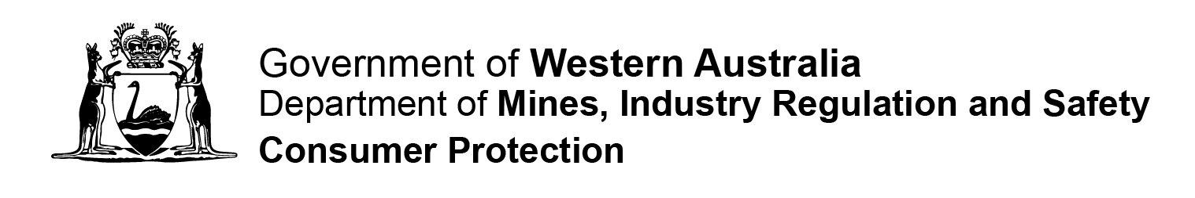

CO-OPERATIVE FORM 14

NOTICE OF CHANGE OF REGISTERED OFFICE
Fm14 P |  | Instructions  Please complete in BLOCK LETTERS. Attach extra pages if needed. All references to dates should be in DD/MM/YYYY format.  Privacy Statement – Please Read  The Department of Mines, Industry Regulation and Safety, Consumer Protection Division (Consumer Protection) is collecting information on this form for the purposes of the Co-operatives Act 2009 (the Act).  In accordance with the Act, a register of this information and any documents lodged with the Registrar will be available for inspection by the public upon payment of a prescribed fee. In other instances, information on this form can be disclosed without your consent where authorised or required by law.

Date Received

Section 243(3)

Part 1 – Notification Details
Section 1  Details | Name of Co-operative………………………………………………………………………….  …………………………………………………………………………………………………….  Registered Number …………………………………………………………………………….  Notice is hereby given that on __ __ / __ __ / __ __ __ __ the registered office of the above named co-operative was changed to and is now situated at:  Address………………………………………………………………………………………….  Suburb………………………………………….. State ……………. Postcode.……………  Phone ( )……………………………… Fax ( )…………………………………………  Email..……………………………………………………………………………………………
Part 2 – Notifying Party
Name and Contact Details  Preferred contact method:  Mail  Phone  Email | Title: Mr Mrs Ms Miss Other (specify)……………………..  Name of Applicant………………………………………………………………………………  Address …………………………………………………………………………………………  Suburb ………………………………………….. State…………. Postcode …………….  Phone ( )………………………… Fax ( )………………………..  Signature ……………………………………………………. Date __ __ / __ __ / __ __ __ __
Lodgement Details
Please Note
This notice must be lodged within 28 days after changing the registered office address.
No registration fee is applicable, however this form may incur an additional fee imposed by the Registrar for late filing of a document required to be lodged under the Act.
Should you require further assistance please contact our office on 1300 304 074
 | Lodgement by Mail:  Department of Mines, Industry Regulation and Safety  Consumer Protection Division  Associations & Charities Branch  Locked Bag 100  EAST PERTH WA 6892 |  | Lodgement in Person:  Department of Mines, Industry Regulation and Safety  Consumer Protection Division  Level 1, Mason Bird Building  303 Sevenoaks Street  CANNINGTON WA

