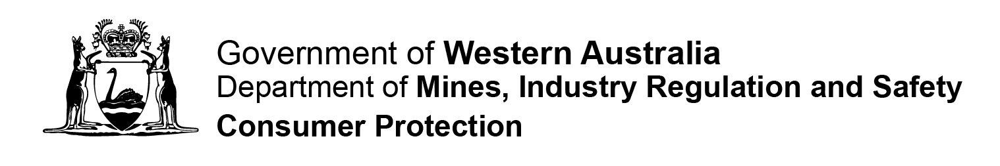

CO-OPERATIVE FORM 02

APPLICATION FOR APPROVAL OF DISCLOSURE STATEMENT
Fm02 P |  | Instructions  Please complete in BLOCK LETTERS. Attach extra pages if needed. All references to dates should be in DD/MM/YYYY format.  Privacy Statement – Please Read  The Department of Mines, Industry Regulation and Safety, Consumer Protection Division (Consumer Protection) is collecting information on this form for the purposes of the Co-operatives Act 2009 (the Act).  In accordance with the Act, a register of this information and any documents lodged with the Registrar will be available for inspection by the public upon payment of a prescribed fee. In other instances, information on this form can be disclosed without your consent where authorised or required by law.

Date Received

Section 16

Part 1 – Application Details
Section 1  Application Details | Name of co-operative or proposed co-operative:  ……………………………………………………………………………………………………  …………………………………………………………………………………………………….  Please note: This form is only required for a proposed co-operative which intends to be distributing co-operative or has been directed by the Registrar to prepare a disclosure statement.
Section 2  Details of Disclosure Statement  The disclosure statement contains the information necessary to ensure prospective members are adequately informed of the nature and extent of a person’s financial involvement or liability as a member of the co-operative. | I……………………………………………………. have attached a copy of the draft disclosure statement and certify that the following matters required by section 16(3) of the Act have been provided for in the draft disclosure statement:  - The estimated costs of formation;  - The active membership provisions of the proposed co-operative;  - The rights and liabilities attaching to shares in the proposed co-operative;  - The capital required for the co-operative at the time of formation;  - The projected income and expenditure of the co-operative for its first year of operation;  - Information about any pre-registration contractual obligations of the co-operative under Part 3 Division 5 of the Act; and  - Other document (please specify) …………………………………………………..  I confirm that the formation meeting is due to be held on __ __ / __ __ / __ __ __ __ and certify that all information contained in this application is true and correct.  Signature of Applicant ………………………………………Date __ __ / __ __ / __ __ __ __  Please note: Section 16(4) of the Act requires that the disclosure statement cannot include a statement purporting to be made by an expert or to be based on a statement made by an expert unless:  - The expert has given, and not withdrawn, his/her written consent to the inclusion of their statement in the submitted disclosure statement; and  - There appears in the disclosure statement a statement that the expert has given, and not withdrawn, his/her consent.

Part 2 – Applicant Contact Details
Applicant Name, Address and Contact Details  Preferred contact method:  Mail  Phone  Email | Title: Mr Mrs Ms Miss Other (specify)……………………..  Name of Applicant………………………………………………………………………………  Address…………………………………………………………………………………………..  …………………………………………………………………………………………………….  Suburb……………………………………………….… State ………. Postcode …………..  Business Phone ( )………………………… Business Fax ( )………………………..  Mobile …………………………………….Email ………………………………………………

Lodgement Details

Please Note:
This application form and the Form 01 Application for Approval of Proposed Rules of a Co-operative must be submitted to the Registrar at least 35 days before the formation meeting is due to be held, or a shorter period as the Registrar may allow in a particular case.
This application should be accompanied by the relevant fee prescribed in the regulations. Please complete Form 99 to submit payment for this fee.
If an applicant wishes to apply for a shorter period to submit this application, they must lodge Form 12 with Consumer Protection accompanied with the fee prescribed in the regulations.
Should you require further assistance please contact our office on 1300 304 074 or (08) 6552 9300
 | Lodgement by Mail:  Department of Mines, Industry Regulation and Safety  Consumer Protection Division  Associations & Charities Branch  Locked Bag 100  EAST PERTH 6892 | Lodgement in Person:  Department of Mines, Industry Regulation and Safety  Consumer Protection Division  Level 1, Mason Bird Building  303 Sevenoaks Street  CANNINGTON WA

