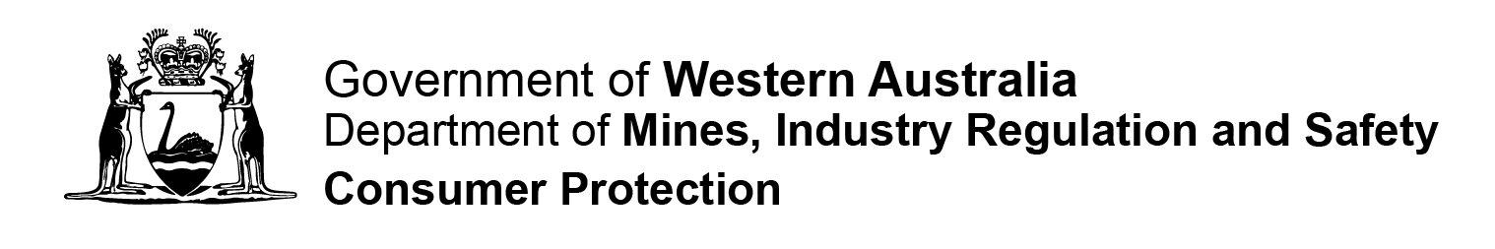

CO-OPERATIVE FORM 72

APPLICATION FOR VOLUNTARY DEREGISTRATION OF A CO-OPERATIVE
Section 601AA of the Corporations Act 2001 (Cwth) as applied by section 316
Fm72 P |  |  | Instructions  Please complete in BLOCK LETTERS. Attach extra pages if needed. All references to dates should be in DD/MM/YYYY format.  Privacy Statement – Please Read  The Department of Mines, Industry Regulation and Safety, Consumer Protection Division (Consumer Protection) is collecting information on this form for the purposes of the Co-operatives Act 2009 (the Act).  In accordance with the Act, a register of this information and any documents lodged with the Registrar will be available for inspection by the public upon payment of a prescribed fee. In other instances, information on this form can be disclosed without your consent where authorised or required by law.

Date Received

Section 316

Part 1 – General Details
Section 1  Co-operative Details | Name of Co-operative: ……………………………………………………………………….  …………………………………………………………………………………………………….  Co-operative Registration Number: ………………………………………………….……
Part 2 - Declaration
* delete as appropriate  Preferred contact method:  Mail  Phone  Email | I ……………………………………………………………………………………..(insert name)  being a: (choose one option)   director  chief executive officer secretary other ………………………………  of the above co-operative am authorised by the co-operative to apply to deregister the  co-operative under section 316 of the Act.  I declare that the statements below are correct:  - All members of the co-operative agree to the deregistration; and  - the co-operative is not carrying on business; and  - the co-operatives assets are worth less than $1,000; and  - the co-operative has paid all fees and penalties payable under this Act; and  - the co-operative has no outstanding liabilities; and  - the co-operative is not a party to any legal proceedings  - I have attached documentation supporting that all members of the co-operative agree to deregistration  I certify that that all information contained in this report is true and correct.  Signature ………………………………………………… Date __ __ / __ __ / __ __ __ __  Address ………………………………………………………………………………………….  …………………………………………………………………………………………………….  Suburb……………………………………………….… State ………. Postcode …………..  Phone ( ) ………………………………….. Fax ( ) ……………………………………  Email: …………………………………………………………………………………………….
Lodgement Details
Please Note
No registration fee is applicable.

Should you require further assistance please contact our office on 1300 304 074
 |  | Lodgement by Mail:  Department of Mines, Industry Regulation and Safety  Consumer Protection Division  Associations & Charities Branch  Locked Bag 100  EAST PERTH WA 6892 |  | Lodgement in Person:  Department of Mines, Industry Regulation and Safety  Consumer Protection Division  Level 1, Mason Bird Building  303 Sevenoaks Street  CANNINGTON WA

