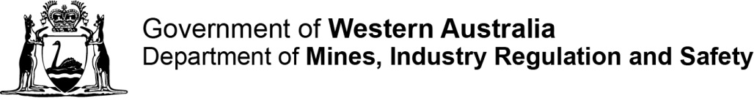
Building Services (Complaint Resolution and Administration) Regulations 2011 – Regulation 18(3) – Refunds of Building Services Levy
‘Exceptional circumstances’ – definition and qualifying framework
Background
This framework document has been devised to set out what might be considered ‘exceptional circumstances’ with reference to Regulation 16(3) of the Building Services (Complaint Resolution and Administration) Regulations 2011, which states:
16. Refund of levy
[…]
- The Building Commissioner may refund all or part of an amount of building services levy that has been paid in a particular case if the Building Commissioner is satisfied that exceptional circumstances warrant the refund being given in that case.
It should be noted that any application for a refund made for Building Services Levy (BSL) under this Regulation will be considered on a case by case basis and on the individual merits presented.
Definitions
In relation to what may constitute exceptional circumstances, there is no precise definition. However, some interpretations are as follows:
Exceptional circumstances: An unusual situation which is not ordinary for a particular place or time. TheLaw.com Dictionary
Exceptional circumstances: are the conditions required to grant additional powers to a government so as to alleviate, or mitigate, unforeseen or unconventional hardship. Wikipedia
Legal commentary
The High Court in Baker v R (2004) 223 CLR 513 at [173] stated: Speaking of the expression "exceptional circumstances" in section 2 of the Crime (Sentences) Act 1997 (UK) required for a decision not to impose a sentence of life imprisonment, Lord Bingham of Cornhill CJ said in R v Kelly (Edward)242:
“We must construe exceptional “as an ordinary, familiar English adjective, and not as a term of art. It describes a circumstance which is such as to form an exception, which is out of the ordinary course, or unusual, or special, or uncommon. To be exceptional a circumstance need not be unique, or unprecedented, or very rare; but it cannot be one that is regularly, or routinely, or normally encountered.”

Qualifying criteria
In order for the Building Commissioner to be satisfied that a refund of Building Services Levy is justified, it must be due to an exceptional circumstance which has resulted in an inability to fulfil the purpose of the permit.
Situations which might, but are not limited to, being considered exceptional circumstances are as follows:

Where the matter involves the sudden death of a person
Such as the death of the applicant or an immediate family member, resulting in an inability to continue with the permitted works.

Where the applicant is at a special disadvantage

Such as, but not limited to:
- Accidental and permanent disability
- Physical abuse between the interested parties
- Unexpected and unforeseen hardship

Other circumstances

Such as natural disasters, unforeseen serious health issues (e.g. heart attack / terminal cancer diagnosis / stroke) or being a victim of a serious crime or trauma might also be considered exceptional circumstances.
If you are considering submitting a BSL refund application due to exceptional circumstances, but you are not sure if your specific set of circumstances would qualify, please contact the Department to discuss the situation further. We can be contacted by email at BE.Levy@dmirs.wa.gov.au or by phone on (08) 6251 1273.

