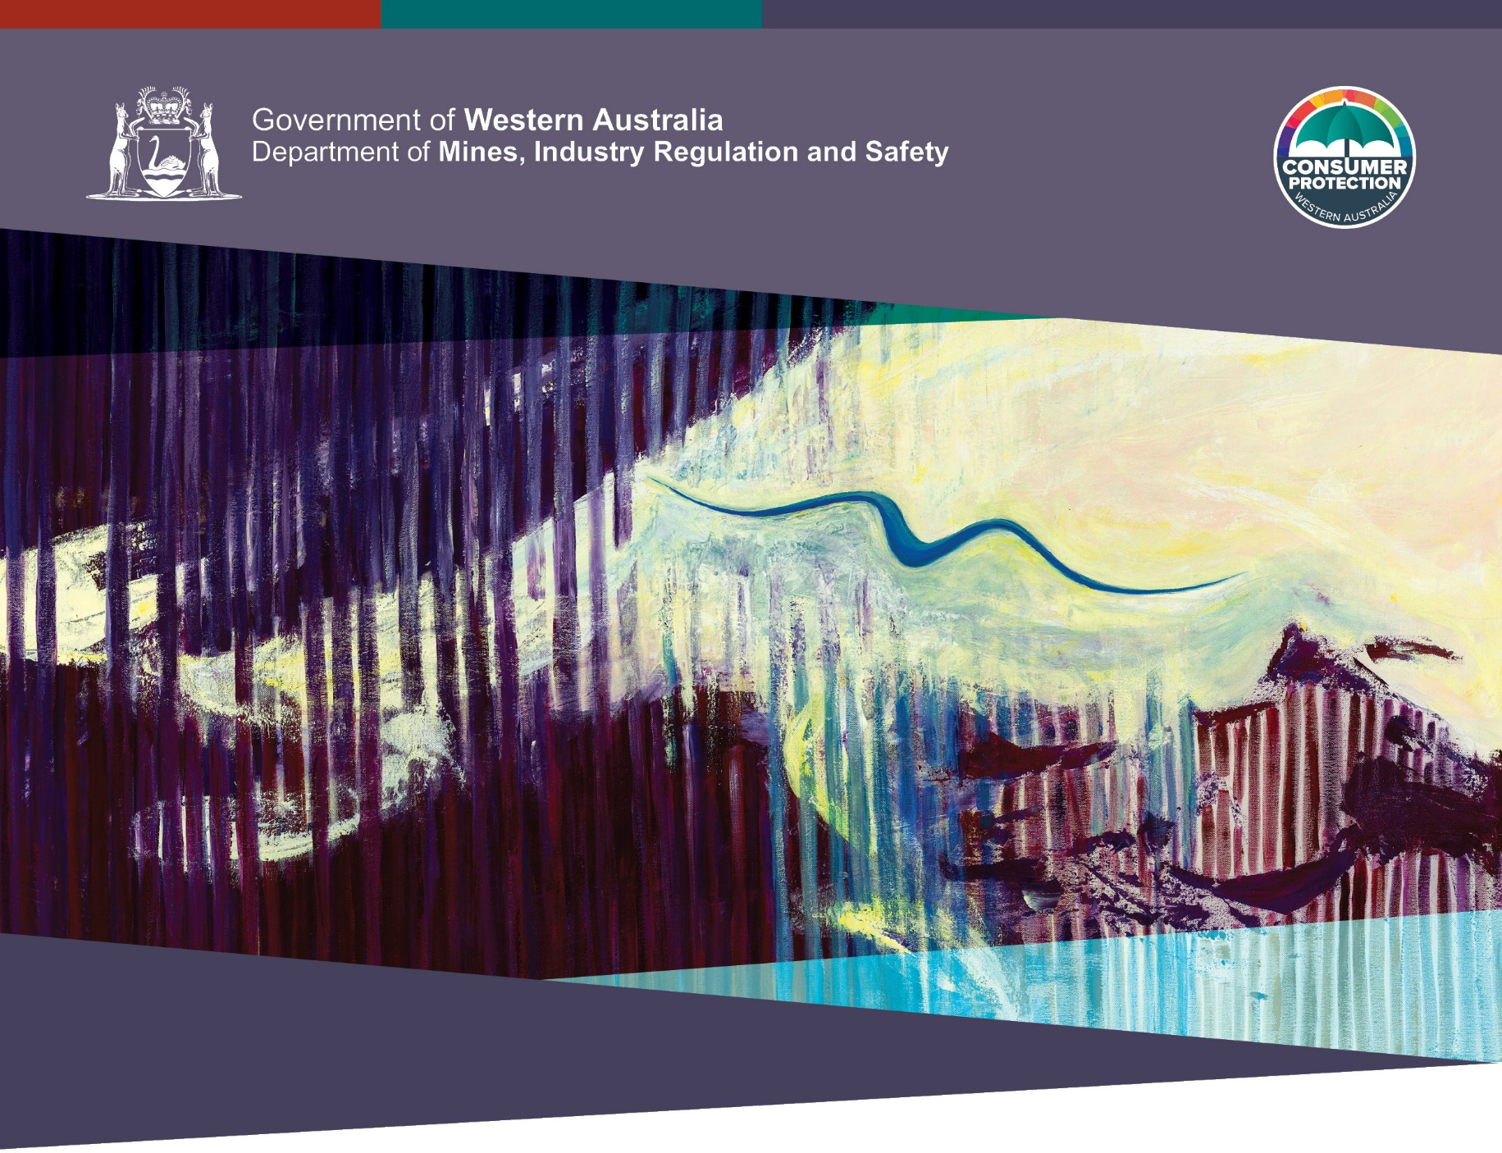
Artwork: Freedom to Fly by Barbara Bynder
WORKBOOK

Statutory review of family domestic violence provisions in residential tenancies and residential parks legislation

November 2022

HAVE YOUR SAY
Written submissions
There is no specified format for written submissions.
Written submissions can be provided via email or by letter.
Submissions using this workbook
You are also welcome to make a written submission by downloading and completing this workbook which includes a series of questions.
There is no need to complete all of the questions.
In completing the workbook, it is suggested that you refer to the matters included in Part 2 of the consultation paper for information relevant to each of the topics.
At the end of this workbook there is an opportunity for you to provide comment on anything else you feel is important to improving the family and domestic violence tenancy laws.
Your comments will help us to find out whether the laws are working as intended and will be taken into account in the review report due to be tabled in the Parliament in 2023.
Lodging your submission
You can submit your responses:
By mail: Review of Family Violence Provisions (Tenancy)
Department of Mines, Industry Regulation and Safety (Consumer Protection Division)
Locked Bag 100 East Perth WA 6892
OR

By email: consultations@commerce.wa.gov.au
Online survey
A short online survey is also available on Consumer Protection’s consultation hub.
Survey responses will remain confidential.
Closing date:
Submissions close on Friday, 16 December 2022.
Information provided may become public
As written submissions made in response to this paper may be subject to freedom of information requests, please do not include any personal or confidential information that you do not wish to become available publicly.
Do you give permission for your feedback to be published?
☐Yes ☐No, please keep my submission confidential.
Who are you?
Please tick the box to indicate who you are.
☐Landlord ☐Real Estate Agent/Property Manager
☐Tenant/Family member or friend ☐Support Worker/Advocate
☐Other (please specify) …………………………………………

Matter 1: Rights to recover debts
Question 1  In circumstances where the FDV tenancy laws have been used, have landlords or property managers experienced increased difficulty recovering debts owed by tenants?  For example, debts resulting from rent arrears and damage to property? | ☐Yes ☐No  Please explain the circumstances and difficulty.

Matter 2: Insurance policies
Question 2  Have landlord insurance policies and premiums changed as a result of the FDV reforms implemented in 2019? | ☐Yes ☐No  Please provide details of any changes.

Matter 2: Insurance policies
Question 3  Have landlords experienced increased difficulty in making claims on their insurance policies that directly relate to the FDV tenancy laws? | ☐Yes ☐No  Please describe the difficulty and explain how it relates to the FDV tenancy laws.

Matter 3: Contractual certainty
Question 4  Are you aware of any adverse impact that the FDV reforms have had on certainty in tenancy agreements? | ☐Yes ☐No  Please describe the nature of any impacts with examples.

Matter 4: Impact on co-tenants and landlords
Question 5  Are you aware of any negative effects on tenants other than the perpetrator or victim-survivor in terms of their tenancy agreement? | ☐Yes ☐No  If yes, please provide examples and information about how these co-tenants have been affected.

Matter 4: Impact on co-tenants and landlords
Question 6  Have the FDV tenancy laws created unreasonable obligations for landlords under tenancy agreements? | ☐Yes ☐No  If yes, please provide examples and information about how landlord obligations have been impacted.

Matter 5: Terminating tenancy without penalty
Question 7  Are you aware of situations where a tenant subject to family violence was unaware of the need to issue a notice of termination to the landlord/property manager during the tenancy in order to avoid being liable for debts and damage to the property? | ☐Yes ☐No  Please describe the situation and what occurred.

Matter 5: Terminating tenancy without penalty
Question 8  Do you support the suggested solutions identified in the consultation paper (pages 15 and 16)? | ☐Yes ☐No  Please explain why or why not.

Matter 6: Liability for debts caused by the perpetrator
Question 9  Are you aware of situations where a victim of family violence has paid for damage caused by the perpetrator who was at the property without permission? | ☐Yes ☐No  If so, please describe what happened.

Matter 6: Liability for debts caused by the perpetrator
Question 10  Do you support the suggested solutions identified in the consultation paper (page 17)? | ☐Yes ☐No  Please explain why or why not.

Matter 7: Being recognised as a tenant
Question 11  Are you aware of situations where a tenant subject to family violence has been unable to remain at the property due to not being listed as a tenant on the tenancy agreement? | ☐Yes ☐No  Please describe the situation and the outcome?

Matter 7: Being recognised as a tenant
Question 12  Do you support the suggested solutions identified in the consultation paper (page 19)? | ☐Yes ☐No  Please explain why or why not.

Please provide any suggestions you have for improving the FDV tenancy laws.
Please provide comment here.

The reforms relate to a tenant ending their interest in a tenancy early on the grounds of family and domestic violence and a court subsequently making a determination as to the rights and liabilities of the parties to the agreement.

